Running head: ELECTRONIC SUPPLEMENTARY MATERIAL

Getting a Handle on Eye-Movement Behaviour Towards Isolated Graspable Objects (Electronic Supplementary Material)

Lotje van der Linden, Sebastiaan Mathôt and Françoise Vitu
Laboratoire de Psychologie Cognitive, Aix-Marseille Université, CNRS, Marseille, France

Corresponding author:
Lotje van der Linden
Laboratoire de Psychologie Cognitive (LPC)
CNRS, Université de Provence, UMR 7290
Centre St Charles, Bâtiment 9, Case D
3 place Victor Hugo
13331 Marseille, cedex 03
e-mail address: l.vanderlinden@cogsci.nl
telephone number: +33 4 13 55 09 66
fax number: +33 4 88 57 68 95

Materials
Stimuli, experimental scripts and data are made available on the first author's website: http://www.cogsci.nl/lvanderlinden/

Center-of-gravity calculation
To calculate the center of gravity (CoG) of our stimuli we applied an edge-detection algorithm (i.e. Sobel operator) to the original bitmap image. Next, we calculated the weighted average contrast of the Sobel-filtered image. An example is shown in ESM_Figure 1.
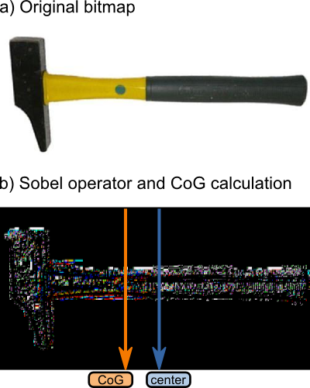ESM_Figure 1: Stimulus bitmap before (a) and after (b) an edge-detection algorithm (Sobel operator) was applied. Compared to the absolute center, the weighted average of the resulting image (CoG) is shifted towards the non-handled side of the object.

Undershoot saccade-target location in Experiment 1
Experiment 1 revealed that, on average, initial saccades did not land exactly at the object's absolute center, nor exactly at its CoG, but rather somewhere in between (see main text). Rather than interpreting this as a high-level bias either towards or away from the handles (depending on the reference point), we should consider the following. Possibly, participants did aim to saccade towards the CoG, but systematically undershot this saccadic target position. This line of reasoning is schematically depicted in ESM_Figure 2.

Saliency maps
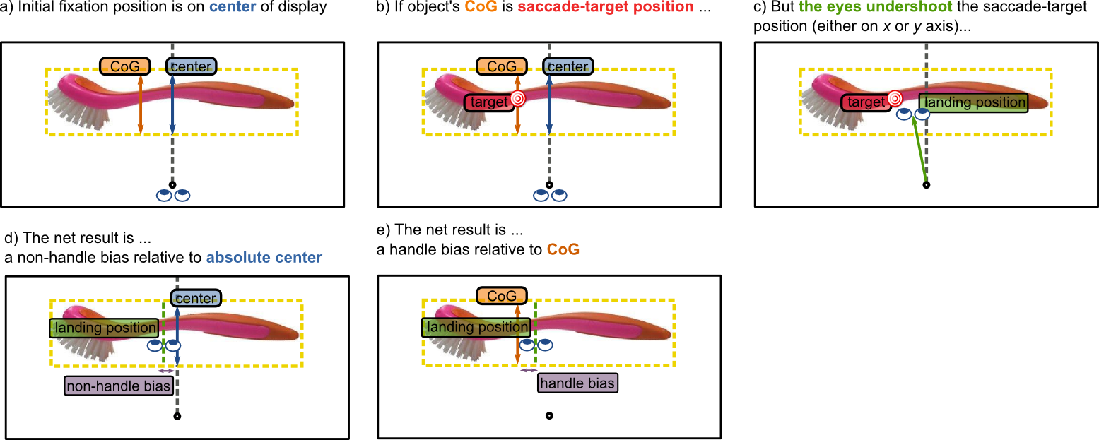ESM_Figure 2: Schematic representation of how a saccade-target undershoot may result in a bias away versus towards objects' handle, depending on the reference point (i.e. absolute center or CoG, respectively).
Saliency maps were generated with the NeuroMorphic vision toolkit (Itti, Koch, & Niebur, 1998). For each image, a saliency map was obtained with the following command:
ezvision --in=[input image] -T --output-frames=0-4@EVENT --out=png --textlog=[output log] -+
Only saccades that crossed an imaginary border between the central fixation point and the smallest-possible target eccentricity were included in the analyses.

Contrast manipulation
Contrast between stimulus and background should influence a stimulus' CoG calculation, as well as its saliency map (Itti et al., 1998). We therefore included a contrast manipulation in our design to investigate (1) whether the CoG calculation and the saliency model are sensitive to this manipulation, and (2) whether participants' eye movements are influenced by this manipulation to a similar extent.
To this purpose, we applied a mask gradient, generated in OpenSesame (Mathôt, Schreij, & Theeuwes, 2012) by usingPsyhoPy (Peirce, 2007), to our stimuli. This led to a degradation of the original stimulus at either the left or the right side (see ESM_Figure 3).
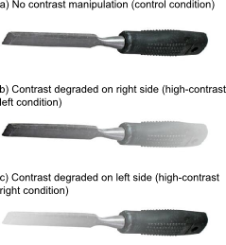ESM_Figure 3: The experimental factor Contrast had three levels: Control (a), High-contrast left (b), and High-contrast right (c).

Contrast effect on CoG calculation
Naturally, the contrast manipulation influenced the CoG calculation. In the control condition (see ESM_Figure 3a), on average the CoG was shifted slightly towards objects' non-handled side (1.25% of the object's width, see also main text). If contrast on the non-handled side was preserved (i.e. contrast on the handled side was degraded, see ESM_Figure 3b), this bias was slightly stronger (1.56%). If contrast on the handled side was preserved (i.e. contrast on the non-handled side was degraded, see ESM_Figure 3c), the average CoG was shifted slightly towards the handle (0.12%).

Contrast effect on initial saccades
Secondly, we investigated the effect of contrast on participants' landing positions. In Experiment 2, objects were presented with their CoG aligned on the vertical meridian. Therefore, we predicted that initial landing positions would not show a deviation from this reference point, regardless of contrast manipulation. Indeed, Bonferroni-corrected (alpha = .05/3) one-sample t-tests revealed that none of the condition means appeared to differ from objects' CoG (t(16) = -0.27, p > .99, t(16) = 0.26, p = .99, and t(16) = 1.65, p = .3552, for high-contrast left, control, and high-contrast right trials, respectively, see blue line ESM_Figure 4a). This suggests that our CoG calculation worked well even when it was performed on stimuli of which contrast with the background was manipulated.
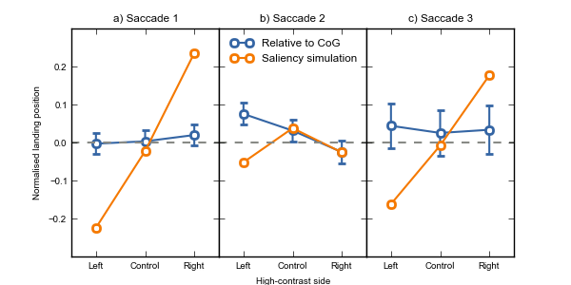ESM_Figure 4: Landing position of observed (blue lines) and simulated (orange lines) initial saccades (a) and refixations (b) as a function of Contrast manipulation (High-contrast left, Control, High-contrast right). Second refixations, although shown in c), were not included in the analyses, because there were not enough second refixations to split per Contrast-manipulation level. Gray-dotted lines indicate objects' CoG, which coincided with the vertical meridian (see also main text). Positive landing positions indicate a rightward bias relative to this reference point, whereas negative values indicate a leftward bias. Note that, in contrast to participants' behaviour (blue lines), a simulation (orange lines) is not subject to between-measures variance. As a consequence, neither statistical testing, nor an indication of error terms (i.e. error bars) was necessary for interpreting the simulated results. For the observed saccades (orange lines) error bars indicate Bonferroni-corrected between-subject confidence intervals (because critical statistical tests were one-sample t-tests rather than within-subjects analyses).

Contrast effect on refixations
Contrast manipulation did affect refixations (see ESM_Figure 4b, blue line). Bonferroni-corrected one-sample t-tests revealed a rightward deviation (relative to the CoG) if the object's right side was degraded (i.e., when contrast with the background was higher on the left side, M = 0.075, SE = 0.012, t(16) = 6.15, p < .0001), and vice versa, although to a marginal extent, if the right side of the object was degraded (M = -0.025, SE = 0.012, t(16) = -1.96, p = .2019). Indeed, a repeated measures analysis of variance confirmed the effect of contrast manipulation on landing positions (F(16,2) = 92.02, p < .0001). Thus, participants looked at the degraded (rather than the high-contrast) part of the object. Although contradictory at first sight, this is probably best explained as a high-level compensatory effect: Participants directed their gaze towards the part of the object that contained less visual information, in order to maximise visual-information uptake. Third saccades (ESM_Figure 4c) were not numerous enough to analyse (≈ 16 observations per cell).

Contrast effect on simulation
In contrast to observed saccades, simulated initial saccades were strongly influenced by the contrast manipulation (see ESM_Figure 4a, orange line), such that they were directed towards the high-contrast (and therefore more salient) side of the object. Then, once fixated, this part of the display was temporarily inhibited, such that subsequent simulated saccades were directed away from the object's high-contrast part (see ESM_Figure 4b, orange line). Finally, for third simulated saccades, initial fixation locations had been partly disinhibited again, resulting in a pattern that is similar, yet less extreme, than the pattern of initial saccades (ESM_Figure 4c versus 3a, orange lines).
Thus, whereas participants' initial saccades appeared to land at the CoG, regardless of contrast manipulation, simulated initial saccades were strongly directed towards the object's high-contrast side. This discrepancy is probably best explained by the fact that the saliency model that we used (Itti et al., 1998) does not take into account the fact that visual acuity rapidly decays as a function of stimulus eccentricity (but see Parkhurst, Law, & Niebur, 2002). As a consequence, the saliency model shows an extreme bias towards the object's more salient side, whereas participants' initial saccades appear to be the result of averaging across visual information in the periphery.

Distributions of landing positions
The current study revealed that, on average, initial saccades are directed towards the object's CoG (see main text, Figure 2b, straight line, first marker), rather than towards the object's handle (as predicted by the handle-affordance hypothesis) or towards the implied action direction (as predicted by the action-direction hypothesis). However, from this finding alone, we cannot yet conclude that the objects' CoG was indeed also the most likely landing position on an individual saccade level. Instead, the average landing position might be the net result of participants moving their eyes either towards the object's handled side or towards the object's non-handled side, with (more or less) equal probability. To distinguish between these possibilities we plotted the distributions of the different landing positions, and reasoned as follows: If initial saccades are indeed most likely to be directed towards the CoG, initial landing positions should be distributed unimodally around this location. If, instead, on a saccade-by-saccade basis, participants either gazed at the handled side or the non-handled side (but not at the CoG), initial landing positions should show a bimodal distribution.
In line with the former, participants' landing positions appear to be unimodally distributed (see ESM_Figure 5a, b and c, left row). More specifically, in Experiment 1, initial landing positions appear to be skewed towards the non-handled side (relative to the absolute center, see first red distribution) or the handled side (relative to the CoG, see first green distribution). Importantly, in Experiment 2, where the chance of saccadic undershoot was minimised, initial landing positions appear to be normally distributed around the CoG (see first orange distribution). All refixations appear to be skewed towards the non-handled side of the object, irrespective of the reference point (see ESM_Figure 5a, b and c, middle and right row). In contrast, simulated landing positions appear to be less normally, and much more widely, distributed (see ESM_Figure 5d). The latter is important, because it indicates that our stimuli were not systematically more salient on one side or the other. Thus, it is unlikely that the systematic bias in refixations is partly explained by low-level saliency.
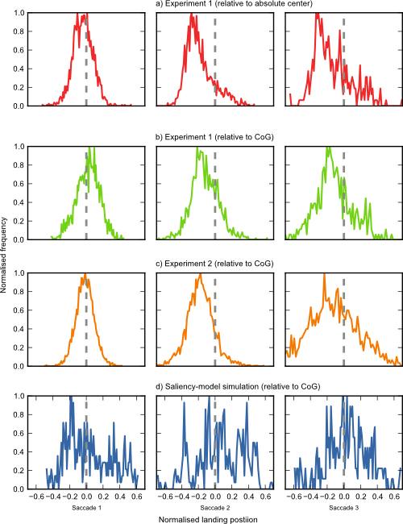ESM_Figure 5: Distributions of landing positions for Experiment 1 (a and b), Experiment 2 (c) and the saliency-model simulation (d), for initial saccades (left column), and refixations (middle and right column).
Figure 1: Distributions of landing positions for Experiment 1 (a and b), Experiment 2 (c) and the saliency-model simulation (d), for initial saccades (left column), and refixations (middle and right column).

References

Itti, L., Koch, C., & Niebur, E. (1998). A model of saliency-based visual attention for rapid scene analysis. IEEE Transactions on Pattern Analysis and Machine Intelligence, 20(11), 1254–1259.
Mathôt, S., Schreij, D., & Theeuwes, J. (2012). OpenSesame: An open-source, graphical experiment builder for the social sciences. Behavior Research Methods, 1–11.
Parkhurst, D., Law, K., & Niebur, E. (2002). Modeling the role of salience in the allocation of overt visual attention. Vision Research, 42(1), 107–123.
Peirce, J. W. (2007). PsychoPy—psychophysics software in Python. Journal of Neuroscience Methods, 162(1), 8–13.

